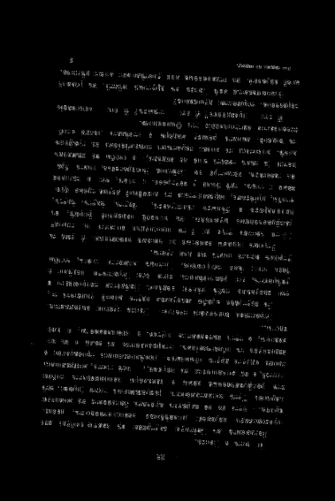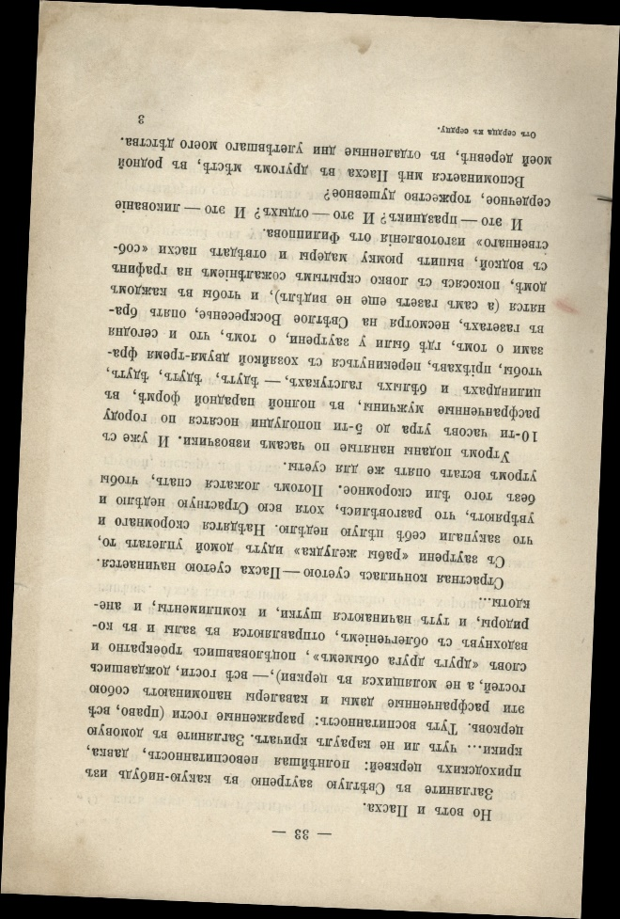First Image:

1

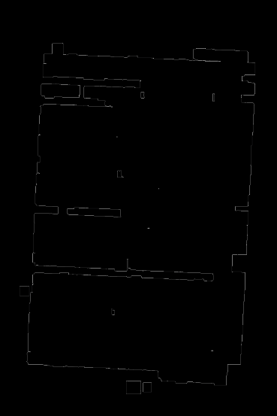

1. Original Image
2. Edge detection using Canny
3. Perform increasingly aggressive dilation until there are just a few connected components left. Then perform edge detection on the result
4. Use HoughLinesP to detect the horizontal lines and find the angle
5. Rotate the image based on the angle

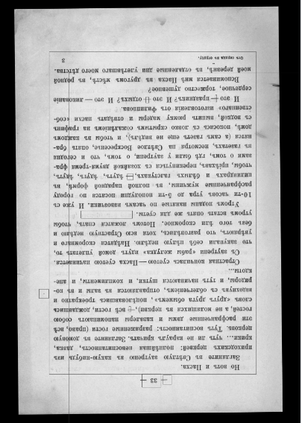

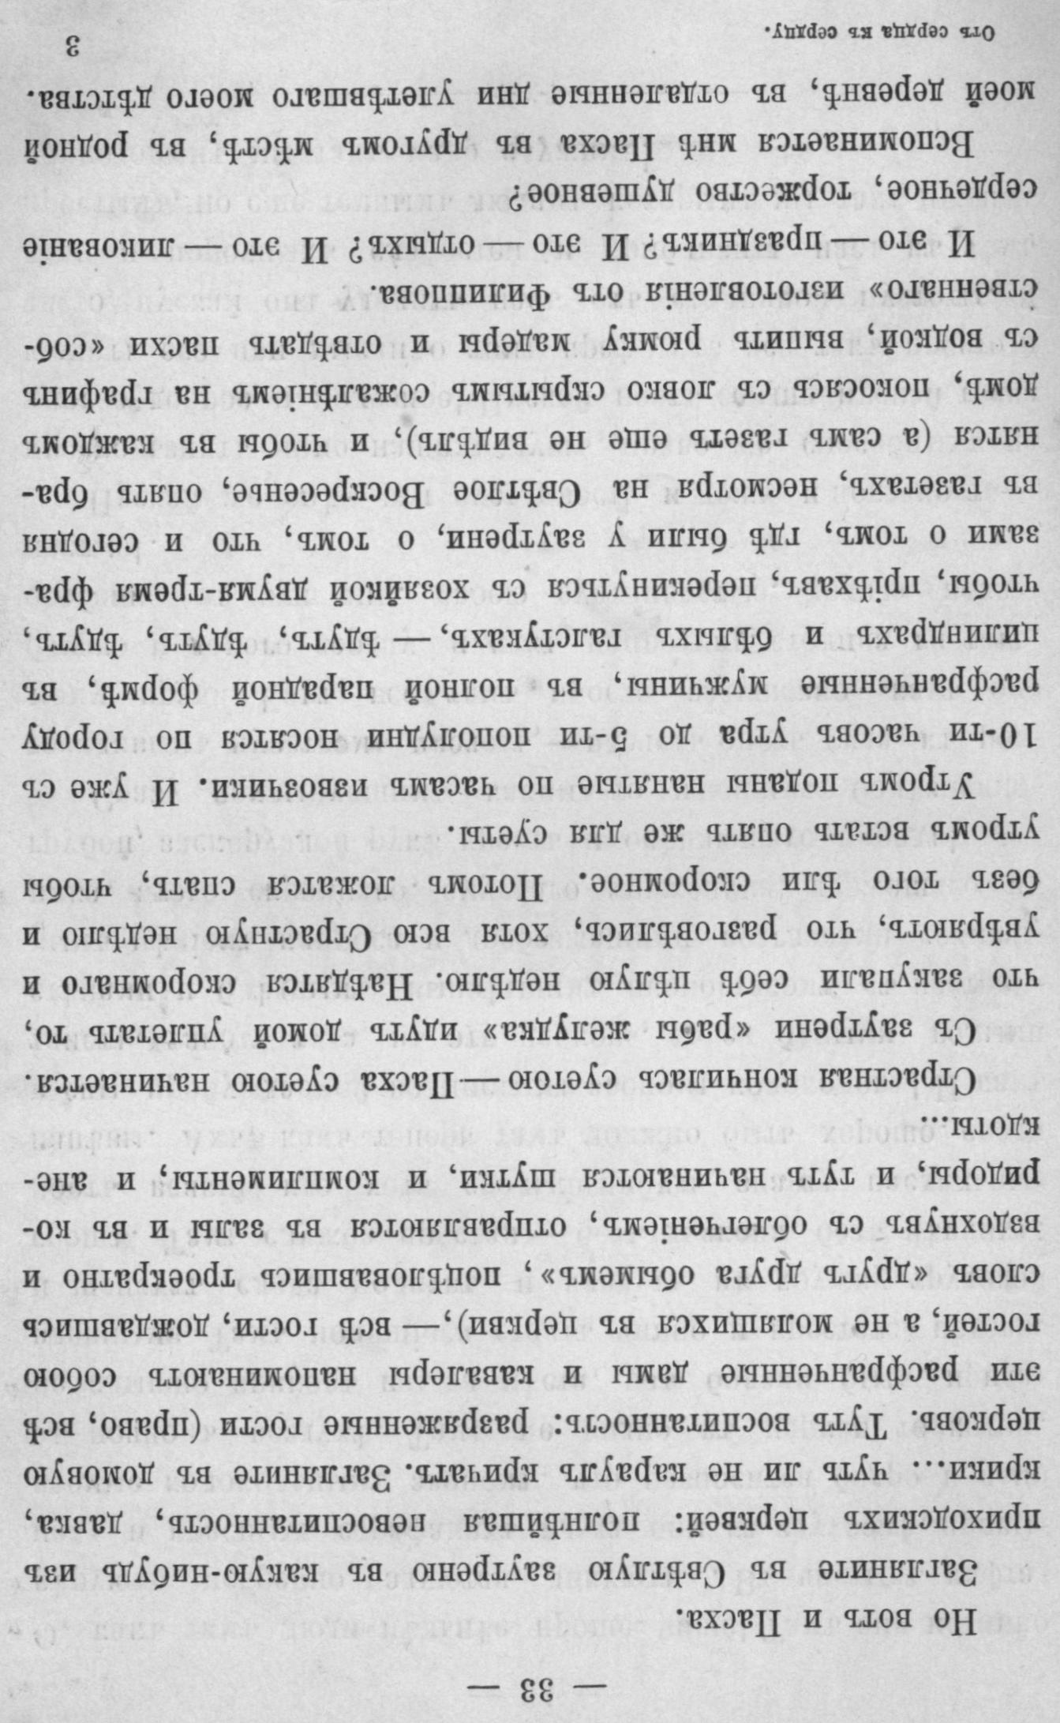

1. Do the dilation again and find the main Contours. Detect the Part of the image that contain text using largest Contours and crop the image to that part
2. I repeat the same procedure for the next image as well

Second Test: (Detect the angle rotate the image, then detect the part that contain the text and crop)

